Grand Solutions Programme 2024:
Process description towards entering an investment agreement

Investment Officer - the project’s contact person in IFD
IFD emphasizes a close dialogue with all project participants to support an efficient and focussed organisation of the project and to increase the probability that the idea and ambitions of the project can be realised.

IFD appoints one or two Investment Officer(s) (IO) who actively follows the project during the preparation of the investment agreement as well as during the investment period. If you have questions for the preparation of the investment agreement incl. exhibits, please contact the IO of the project.

The IO collaborates with the project’s contact person in preparing the investment agreement with exhibits and guides the project participants in the process towards finalising and signing of the Investment Agreement.

The project’s contact person (acting project leader)
The project leader is appointed by the project’s steering committee. Until the steering committee has convened for the first time the project is led by the project’s contact person, who is IFD’s contact during the agreement negotiations. The contact person is responsible for completing the agreement, including exhibits. The contact person is replaced by the project leader after the inaugural steering committee meeting.

The project’s administrator
The administrator, appointed by the steering committee, receives the investment payment from IFD. The administrator is responsible for transferring the payments to the individual project participants, and for producing the financial reports to IFD in cooperation with the project leader. IFD recommends that the university partner (if relevant) will undertake the role as the administrator.

Timeline and deadlines
The project participants and Innovation Fund Denmark (IFD) must sign an investment agreement for the project by 20th March, 2025 (Notice that deadline for approval is March 6th 2025).

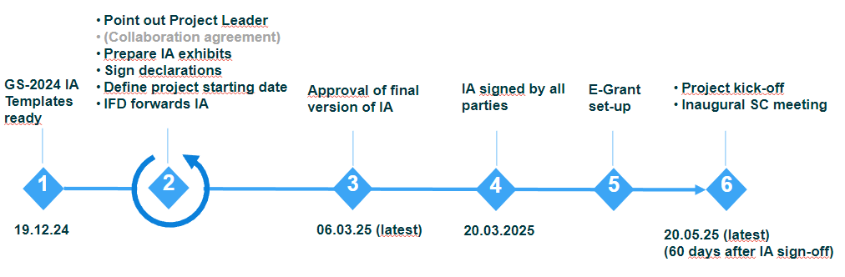

Early January 2025
  - The project’s contact person will receive information material and templates for the investment agreement. The material will also be available on IFD’s web site. The contact person will distribute information to the project participants. NB: In respect of the very short deadline, negotiations between project participants should commence immediately.

Medio February 2025
  - The IO will follow up on progress between the parties.
March 6th 2025
  - Deadline for submission of the investment agreement and exhibits to IFD for final approval. Hereafter, the merged investment agreement is returned to the project’s contact person, who is responsible for the signature process.
  - The project contact person sends the investment agreement including exhibits by e-mail to Investment Officer with indication of case number in the subject text.
March 20th, 2025
  - Final deadline for submission of approved and signed investment agreement to IFD. Upon receiving the agreement, the Vice President of IFD will sign the agreement.
  - Collaboration agreement between the project participants is not an integral part of the investment agreement, but must be agreed upon and signed by the project participants prior to IFD receiving the signed investment agreement.
June 15th 2025
  - The investment period must commence no later than 90 days after the investment agreement has been signed (including IFD) (please see, Investment agreement §13.2).

Collaboration agreement
A collaboration agreement is governing the project participants’ interrelationship, including distribution and utilisation of intellectual property rights developed throughout the project. A collaboration agreement is not an integral part of the IFD investment agreement, but must be agreed upon and entered into by the project participants at the time of the final signing of the investment agreement. Preparing the collaboration agreement is often the most time-consuming part of the investment agreement to negotiate. We recommend that the project participants as soon as possible identify the relevant people to involve in the decision-making process (including possibly legal advisors) and start negotiations. IFD offers an inspirational draft for preparation of collaboration agreement available at IFD’s website.

The collaboration agreement must not be in contradiction to principles in the investment agreement. In event of discrepancy, the investment agreement shall prevail.

NB! Investment agreement including all exhibits must be approved by IFD before the investment agreement can be signed by the project participants.

The signature on the Investment agreement must be verifiable (in the form of a handwritten signature or a digital signature with verification).

Investment agreement and exhibits

IFD prepares the main document of the investment agreement, which will be filled out with the information on project participants and signees supplied by the project’s contact.

Exhibit 1: Project Plan
Exhibit 1 is a tool for the project leader and the steering committee and encompasses a project plan and description of milestones, deliverables and success criteria.

It is often advantageous to base exhibit 1 on the original application to IFD, which is adjusted and made operational as a management tool for the project. The project plan must contain the following information:
- Description of the vision and added value of the project.
- Overall goals and success criteria of the project.
- Overview of the project’s success criteria and overall milestones for the investment period. The interrelationship of milestones must be described.
- Overview of the work packages or sub-projects of the project. For each of these please describe:
  - Milestones, including critical deliverables and potential bottlenecks.
  - Description of any Stop/Go milestones.
  - Content and risk profile of the tasks.
  - Goals and expected results, thus they are Specific, Measurable, Achievable, Realistic, Time- bound (SMART) and preferably quantifiable.
  - The role of individual participants.
  - Use of resources per participant in person months.
- Continuous evaluation – most projects benefit from a continuous project evaluation, where participants revise the project plan, success criteria, project management and budget to ensure continued momentum and the right balance between activities, including commercial and scientific ambitions in the project.

Exhibit 2: Organization and Management
In Exhibit 2 the project’s organisation and management is described including specific information of:
- Acting project leader (name, contact details)
- Work groups and work group leaders (names) if applicable
- Members of steering committee
- Administrators name
- Advisory boards (names) if applicable
- Other management (name, contact details) if applicable

The project leader cannot be a member of the steering committee, but may participate in steering group meetings as an observer. It is recommended that the steering committee chair does not represent the same organisation as the project leader, and that the positions are distributed evenly among the project partners. We acknowledge that naming all roles in the project is not possible before after the inaugural steering committee meeting.

The members of the steering group must have sufficient decision-making power in their own organization to be able to make the necessary decisions on behalf of the partner and solve, for example, lack of resources in the project. The steering group takes care of the strategic management and is not part of the project's day-to-day operations. As a general rule, each project partner appoints one member to the steering group.

Exhibit 3: Budget
Exhibit 3 is based on the budget in the submitted application. Based on the by IFD approved budget, IFD inserts key budget numbers in the Exhibit.

Exhibit 4: Rules of procedure for the Steering Committee
The rules of procedure for the steering committee is attached as exhibit 4 of the investment agreement. The text in the template is not to be changed.

Declarations
Company partners must fill in up to three of the following declarations: 1A) Declaration on status as ‘an undertaking not in difficulty’, 1B) Declaration on De minimis rules of state funding, and 1C) Declaration on status as SME and state funding.

All companies must fill in 1A, companies that apply flat-rate in the budget fills in 1B, and all SME’s fill in 1C.

